Worksheet 21st April 2011
- Please fill in the gaps with the appropriate possessive pronoun.

- Edgar moved ___________ head. “I need _______ head”, he thought.
- The man asked, “What’s wrong with _______ garage?”
- Edgar thought “That’s a nice car he has. I need _______ van.”
- Mr and Mrs Redgick were on _________ way to leave the earth.
- Mrs Redgick was happy. She said to ________ husband.
- Kay and Jay wanted to have a newspaper. Jay said, “Can you buy a newspaper for __________?”

- A ship is going to leave the planet.
Write a conversation between Mr. and Mrs. Redgick about their plans.

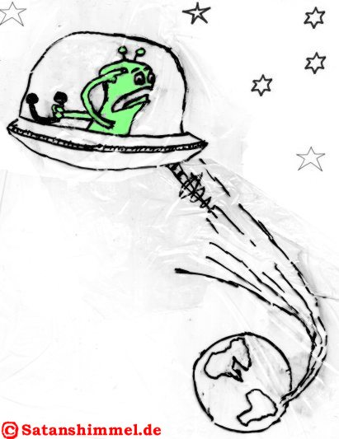

- Put the words in the correct order.

- Rosenberg/out/often/went/cat/with/his.
__________________________________________________________________

- A box/he/took/under one arm.
__________________________________________________________________

- Smiled/and/and/Edgar/killed/Arquillian/Rosenberg.
__________________________________________________________________

- Not/Edgar/up/did/give.
__________________________________________________________________

- A/truck driver/word/a/without/killed/Edgar.
__________________________________________________________________

